Project 2

Deploying Amazon RDS Multi-AZ and Read Replica, Simulate Failover

Step1: Creating an EC2 instance

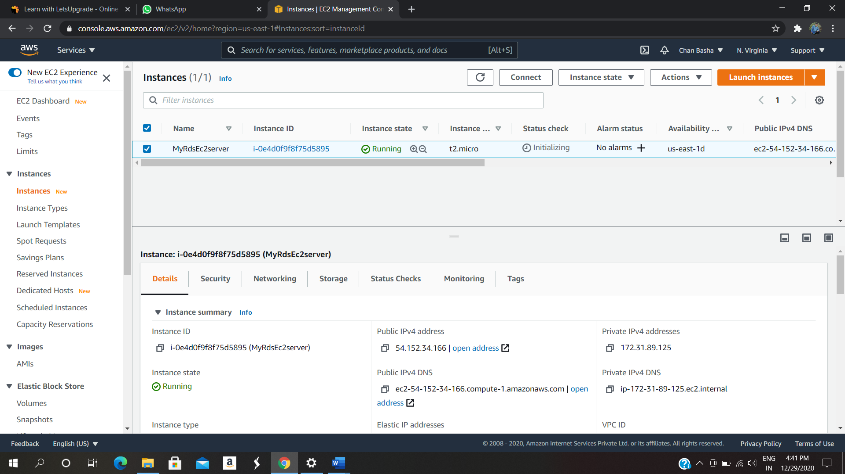

Step 2: Creating a Security Group for RDS instance

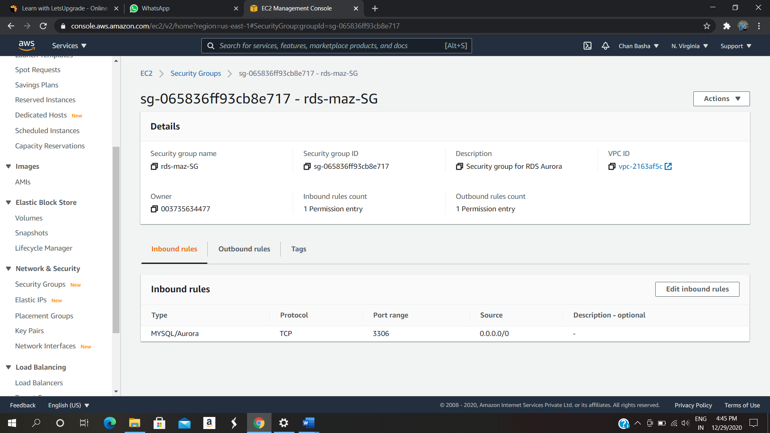

Step 3: Create an Amazon Aurora database with Multi-AZ enabled

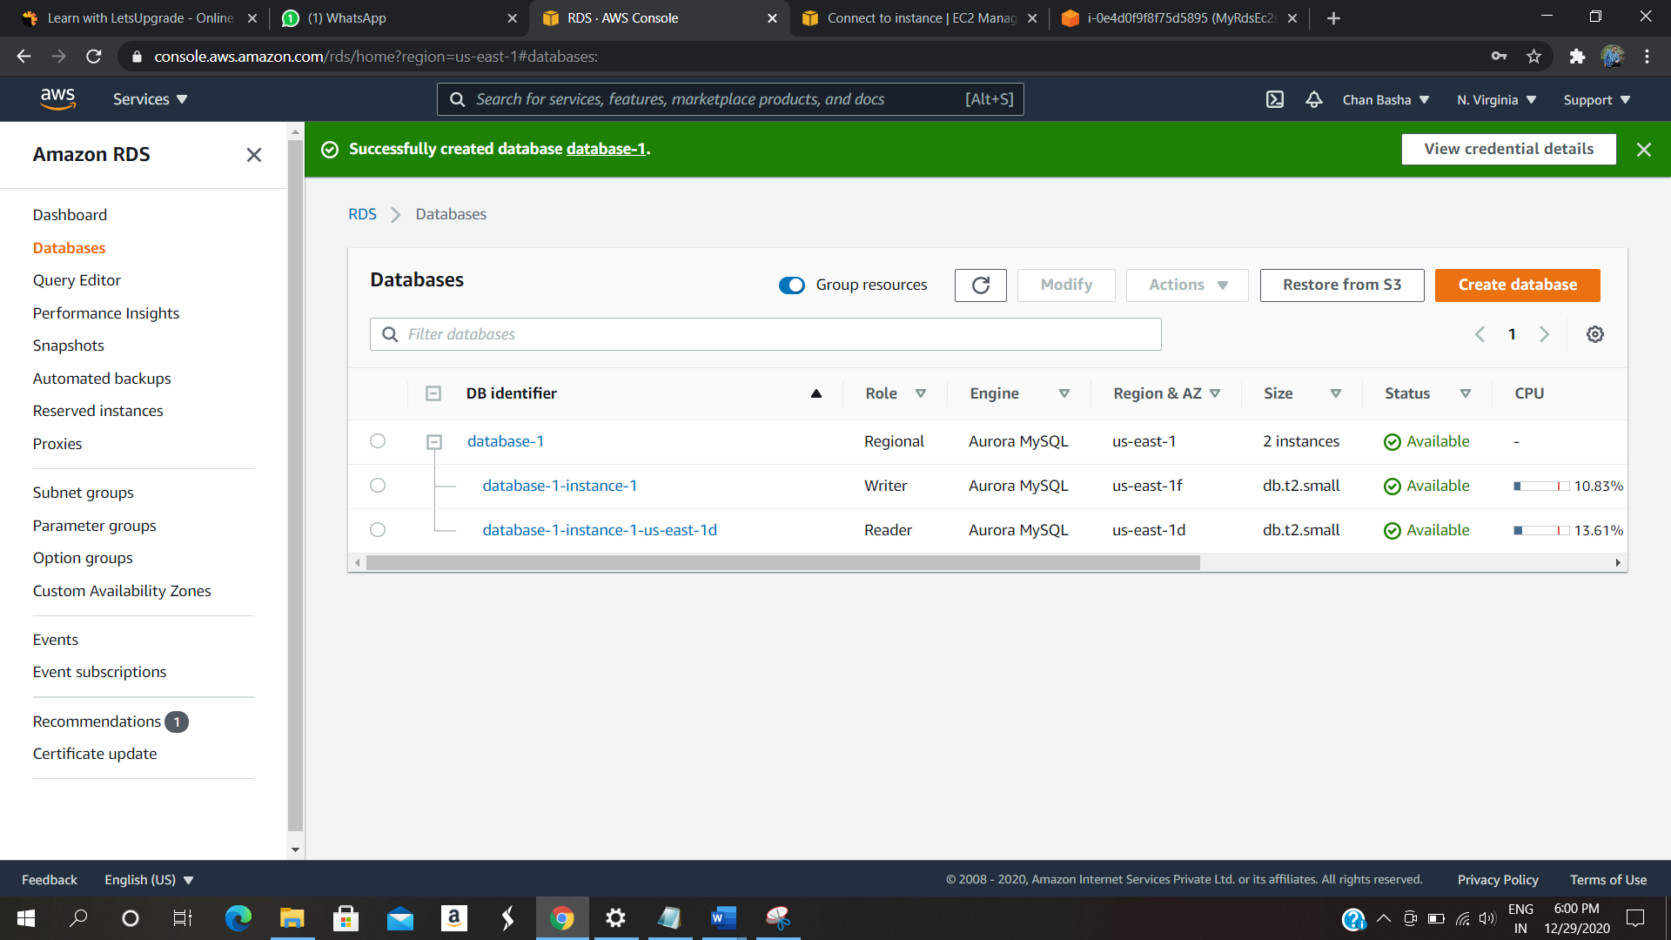

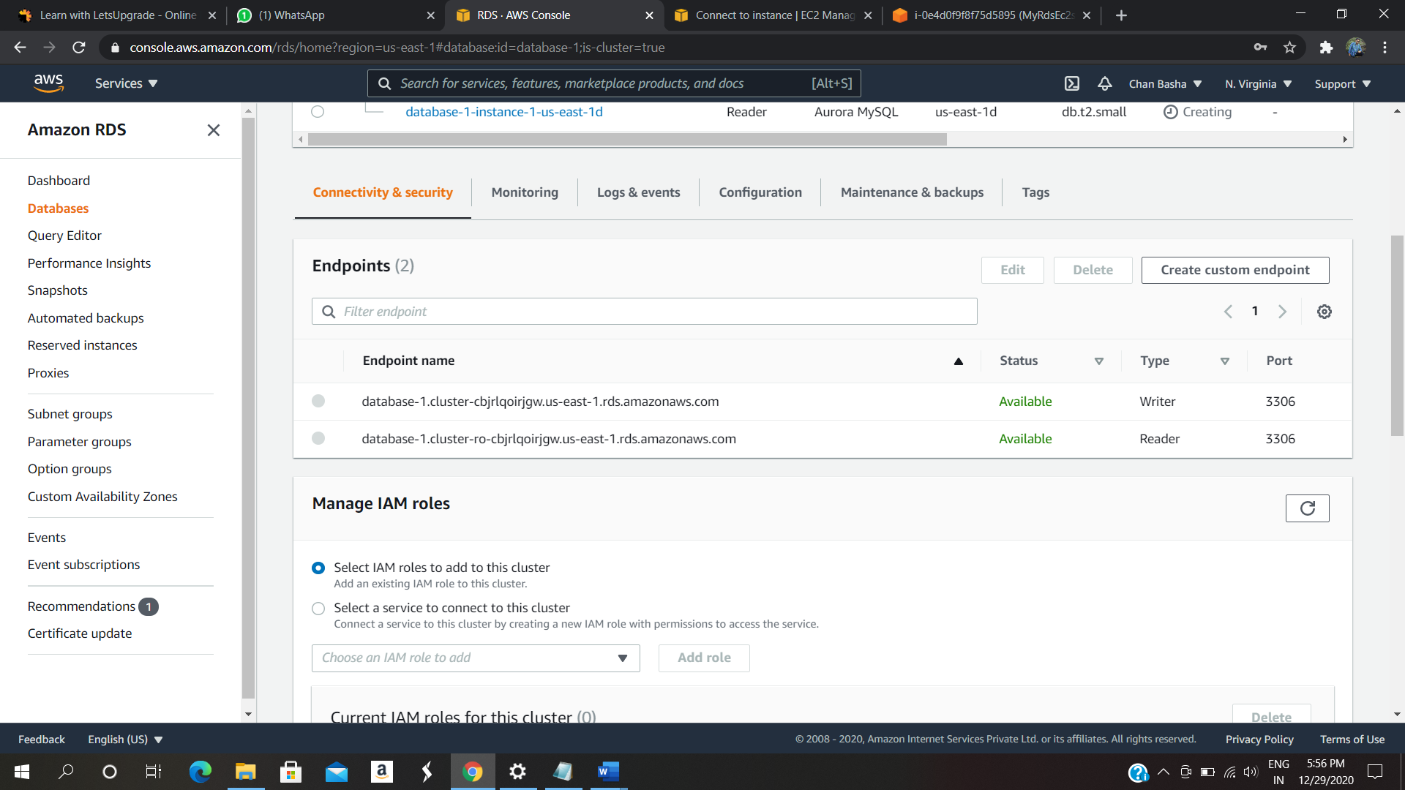

Step 4: Connecting to the Aurora (MySQL) database on RD

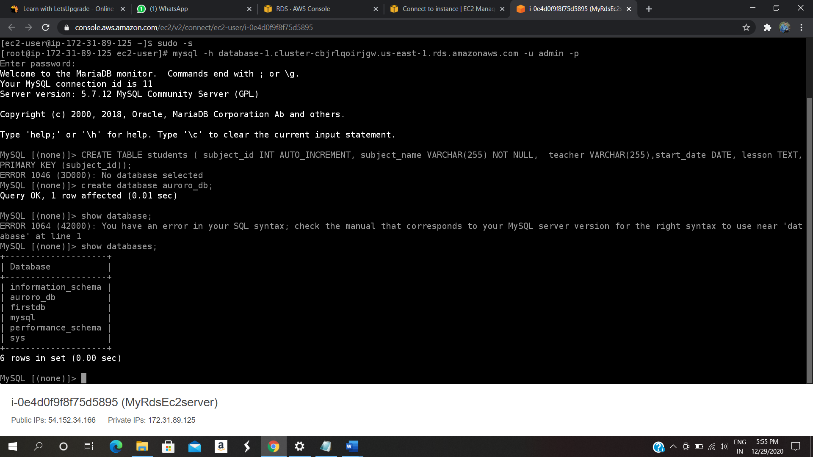

Step 5: selecting data from tables

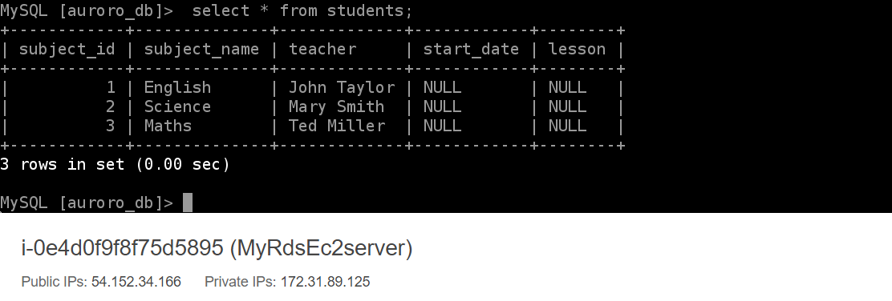

Step 6: Testing Multi AZ failover

Before failover



After failover (wrtier becomes reader and reader becomes writer)

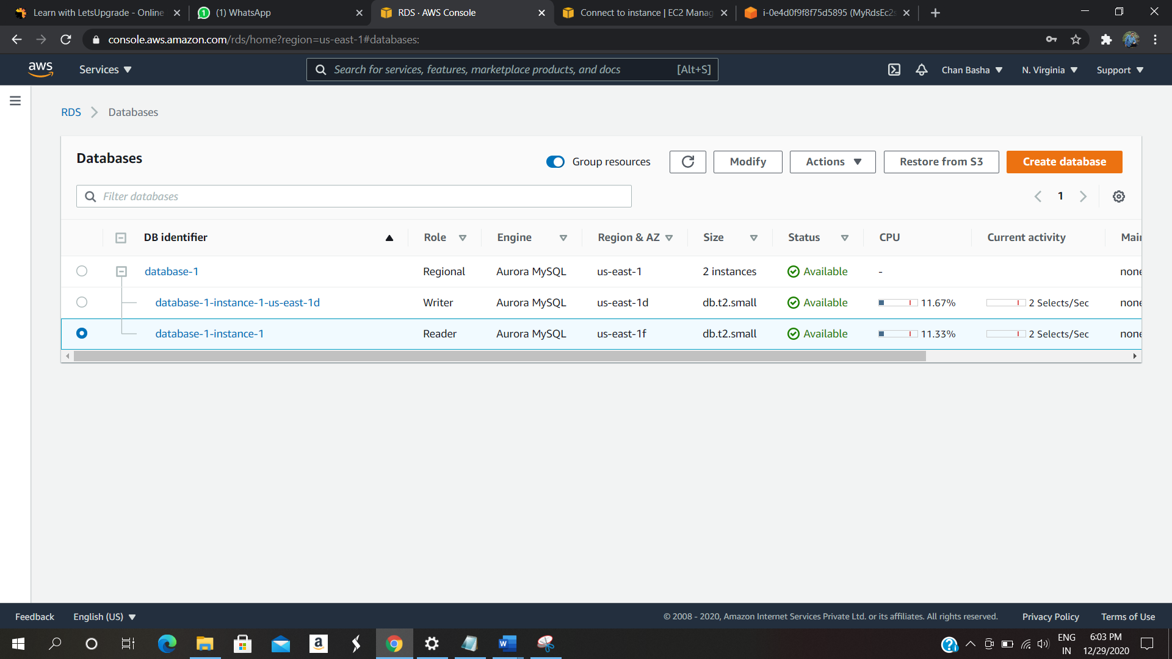

Step 7: Testing the Failover Condition

